* User can access the anonymous payment page for ADSL/Mobile through E-Care page for anonymous payment from below page

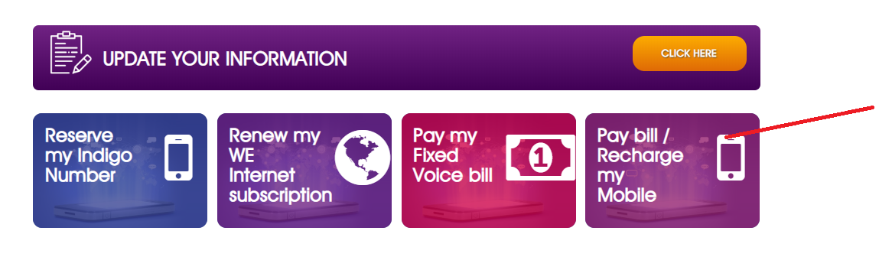

* User will be redirected to below new page to choose mobile payment or ADSL payment:

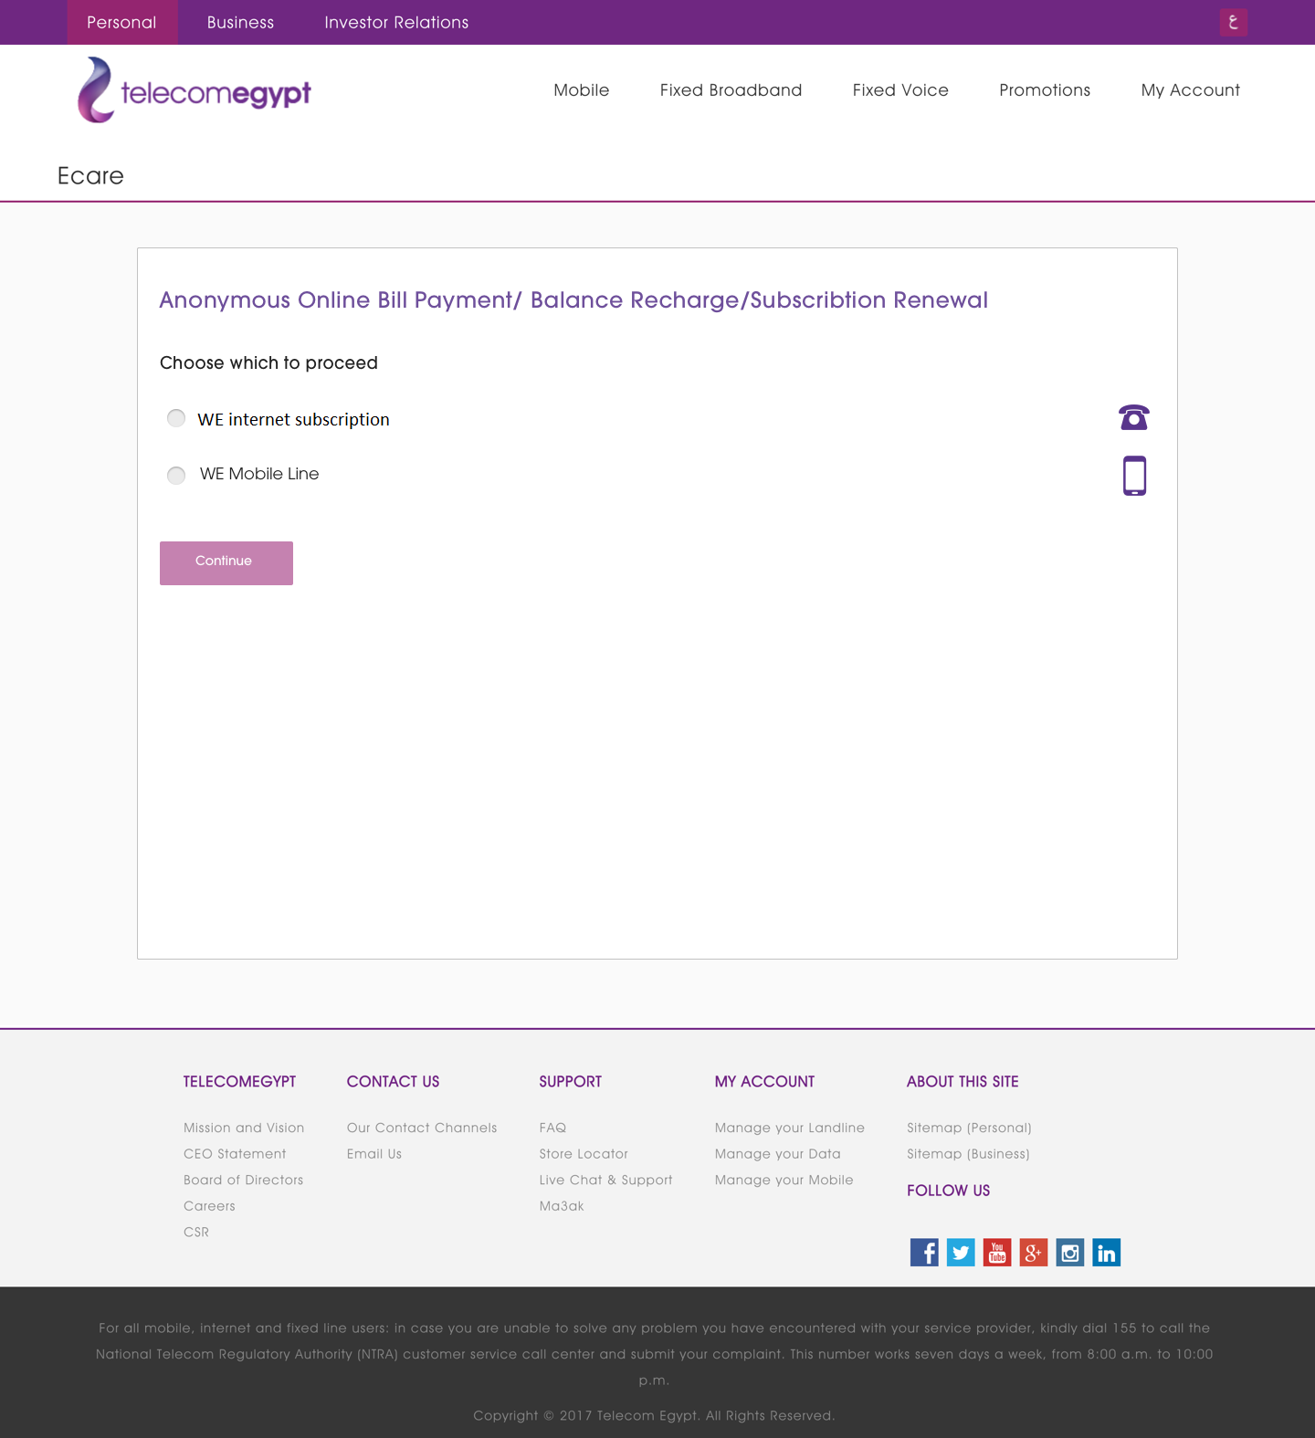

* If user select WE Mobile, user will be redirected to existing page for mobile payment

<https://my.te.eg/#/payment/rechargeAnonymous>

* If user select WE internet, user will be redirected to below NEW page

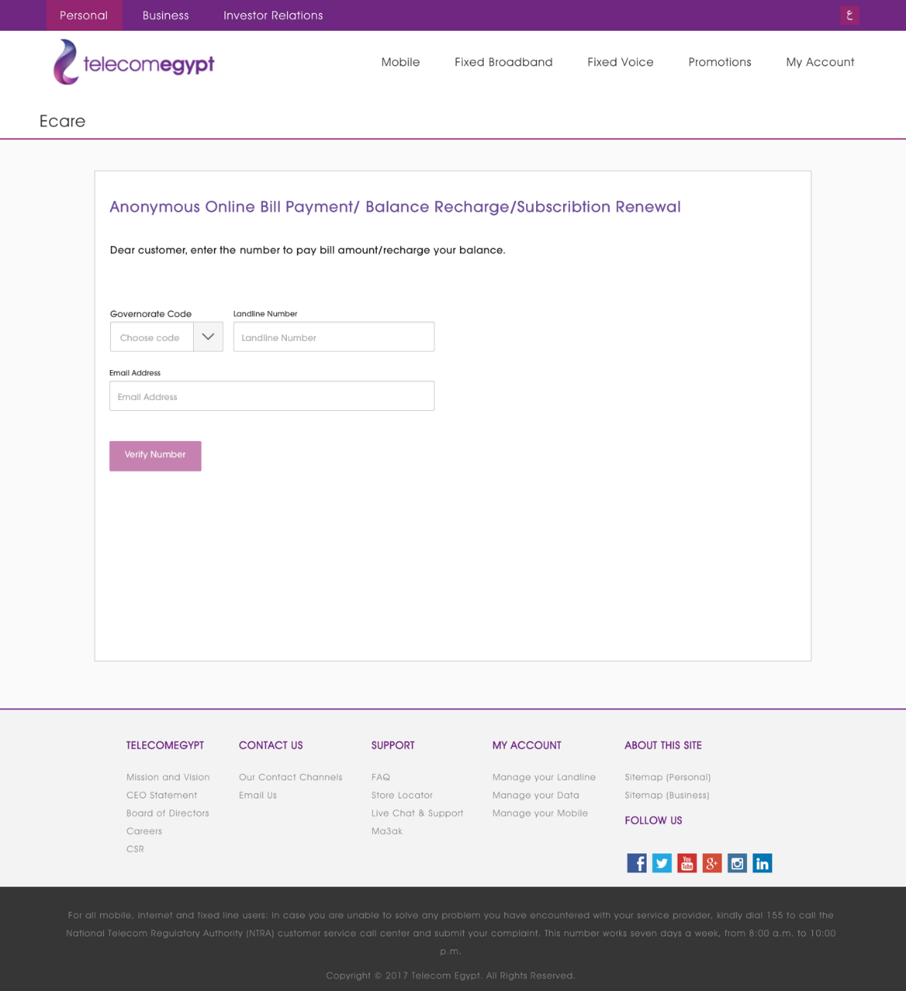

**Validations:**

* + Page will validate only on the landline number length to not be less than 7 digits and not more than 8 digits (excluding governorate code) and email format
  + User must fill all data by choosing governorate, enter landline number and Email.

**(**TE will provide the list of governorates with their codes and sort order**)**.

**APIs:**

* + on page load

>generateToken (Please refer to the external samples file)

>loadGovernates for Loading All Governates Please Make it configured at the Web App side and loaded from your Own configuration

* + On Verify Number

>adslSystemInfo API for getting the below info

(Please refer to the external samples file)

* + - Number type: BSS/SIMBA/Not Valid
    - Redirect URL
* Based on the interface response, E-Care will proceed in one of the following business scenarios:

1. The number is invalid
2. The number belongs to Simba system
3. The number belongs to BSS system

#### In case the number is invalid

* ECARE will display message as follows

English “The landline number you entered does not exist. Please check the number and try again. For help call 111/19777 or click **here** for live support.”

* And in Arabic interface

“رقم الهاتف الأرضي الذي أدخلته غير موجود. من فضلك تأكد من الرقم وحاول مرة اخرى. للمساعدة إتصل بـ19777/111 أو اضغط **هنا** للحصول على الدعم المباشر.

* The words (here and هنا) are both hyperlinked with different color to direct customers to the live chat (Existing page).
* URL for Live Chat is : chat URL [waleed]

#### In case the number belongs to Simba system

* Page system will redirect the user to the existing anonymous payment page (<https://www.mytedata.net/wps/portal/ssp/AnonymousRenewal/>)
* E-Care will pass the data entered by the user to the existing anonymous payment (http post).
* The passed data will be (governorate code, landline number and email address).

#### In case the number belongs to BSS system

* Below new page will be displayed populated with passed phone number, email.

This page can redirected from:

* + - Verify page
    - SIMBA page, passing the (governorate code, landline number and email address)

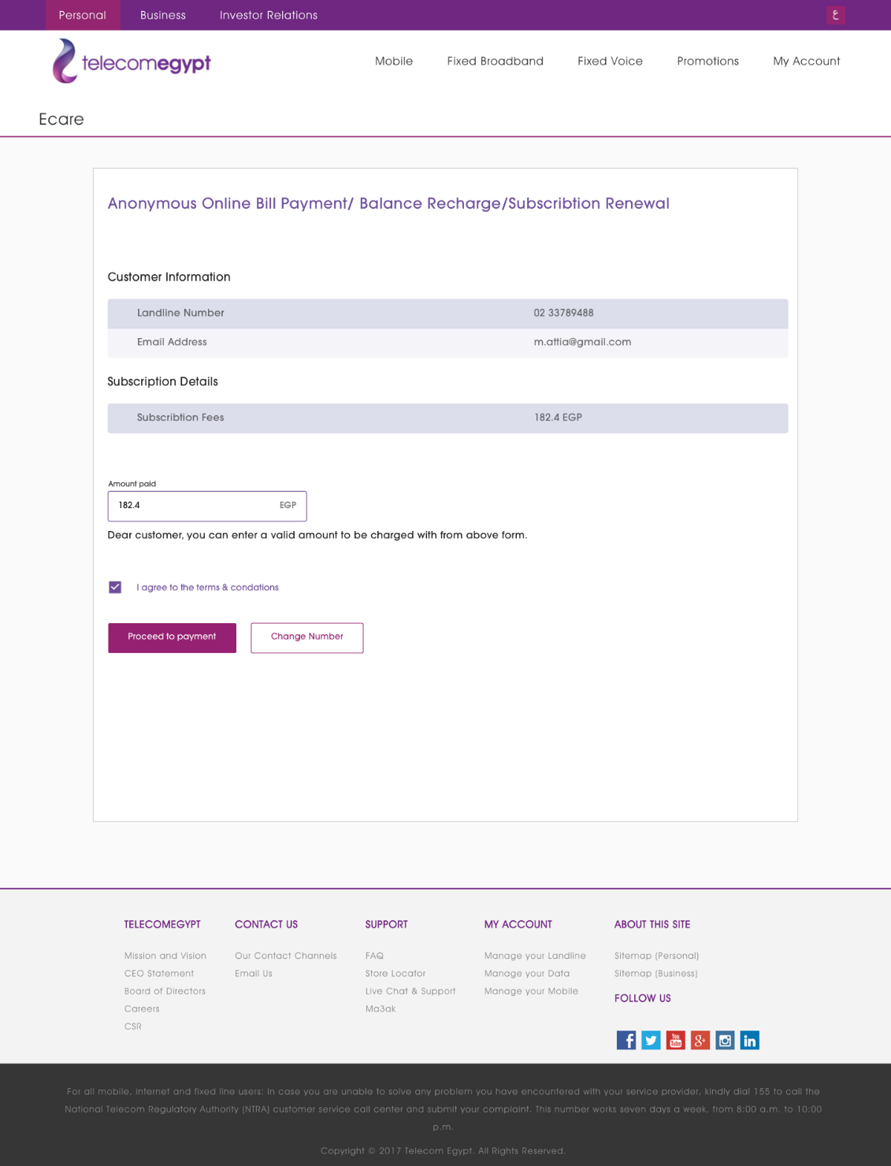

**Validations/Scenario:**

* + No editing allowed in all customer information and subscription details fields.
  + The user may modify “Amount paid” value as the following:
  + There will be no restriction for maximum value of “Amount Paid”
  + E-Care will validate if the entered value is above the minimum value “Minimum amount to be paid”
  + If the entered value less than the minimum amount, E-Care will reject the amount, and display error message:

EN: “The amount paid is less than the minimum payment.”

AR:” المبلغ المدفوع أقل من الحد الأدنى للدفع.”

* + If the entered value above the minimum allowed amount and higher than the invoices amount, E-Care will accept the payment and will display warning message to inform the user with adding the extra amount to his balance as below, then proceed to payment::

EN: “The amount paid is higher than the invoice amount, the extra amount of XXX will be added to your balance.”

AR: “المبلغ المدفوع أعلي من قيمة الفاتورة، سيتم اضافة المبلغ الاضافي *** الى رصيدك.”

* + If the entered value above the minimum allowed amount and less than the invoices amount, E-Care will accept the payment and will display warning message to inform the user that the invoices not fully paid, then proceed to payment:

EN: “The paid amount is less than the invoice amount, please pay the remaining to avoid service disconnection.”

AR: “المبلغ المدفوع أقل من قيمة الفاتورة ، يرجى دفع المبلغ المتبقي لتجنب انقطاع الخدمة.”

* + E-Care will not allow the user to proceed in payment without accepting terms and conditions.
  + If the user press on terms and condition link, E-Care will display the terms and conditions as currently existing by opening new window with the following link in English “<https://www.mytedata.net/wps/wcm/connect/tedata_wcm_library/sa_content/sa_articles/renew_for_others_payment_terms_en>”. (see figure 4)

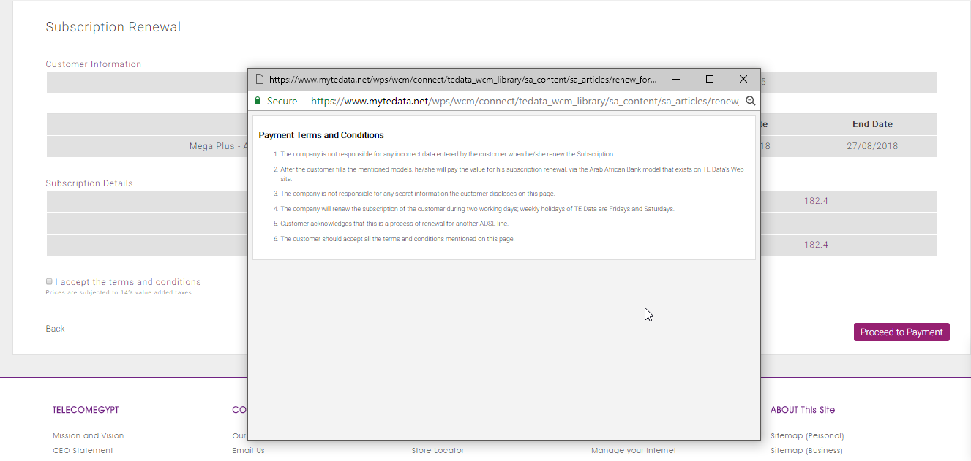

figure 4

And in Arabic <https://www.mytedata.net/wps/wcm/connect/tedata_wcm_library/sa_content/sa_articles/renew_for_others_payment_terms_ar> (see figure 5)

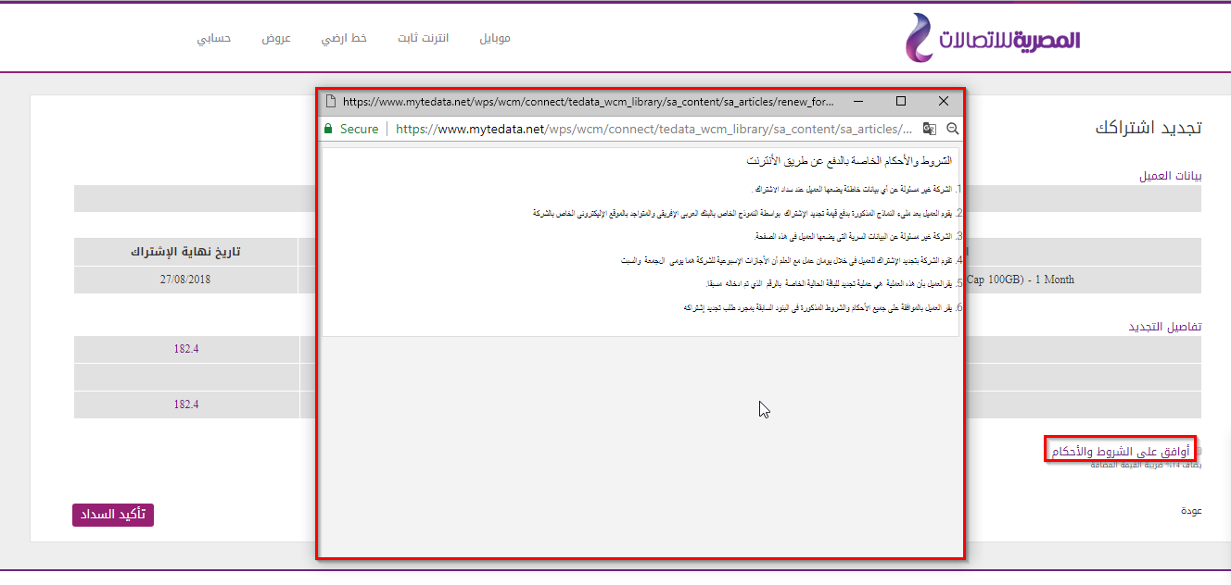

figure 5

* + After accepting Terms and conditions and pressing on confirm button, E-Care will generate the hash code then direct the user to Payment interface using the generated hash code.
  + Payment interface will return the transaction reference to E-care
  + E-Care will display payment confirmation page – To be provided by TE
  + If user needs to change the number, he has to press “change Number” button.

Redirect to verification page with empty values.

**APIs:**

* + on load page

1-In case that page were reached through redirect from SIMBA, you need to have a new Token, please call generateToken,

2-Call adslPaymentInfo API to get below info

(Please refer to the external samples file)

* + - Minimum amount to be paid
    - Subscriber Type: Prepaid/Postpaid
    - Subscription Fee

3-Display the posted information above either from SIMBA or from your previous page (governorate code, landline number and email address)

* + on proceed to payment

PaymentAPI-Initiate, generate hash code (Initiate payment API)

(Please refer to the external samples file)

* + After receiving payment interface response

PaymentAPI-Finalize (Finalize Payment API)

(Please refer to the external samples file)